(OOP Project)



Covid-19 Resource Center

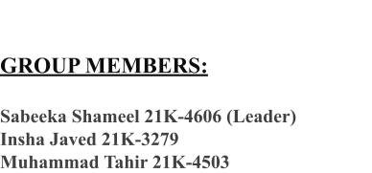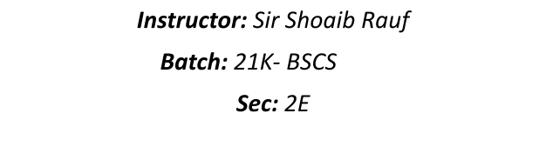

This project will be submitted as a partial requirement for the course CS-217 in spring 2022.

***Introduction***

**System User(s):**

1. Paramedical staff / Hospitals / Vaccination Centers.
2. Citizens

**For Hospitals / Centers / Mobile Units:**

* Supply of Covid-19 vaccines to hospital, Centers & mobile units.
* Availability of Doctors (their duty timings)

**For Citizens:**

* Covid-19 vaccination services & information to Citizens. Such as:
* Pre-Registration for vaccines.
* Availability of different Covid vaccines.
* Recommended Doses.
* Nearest Hospital/Mobile Units for vaccination.
* Providing with a booking code when eligible for the next vaccine dose.
* Next dose reminder.
* Can check his or her status of vaccination registration.

**Additional Feature:**

* Covid-19 statistics such as:
* Active Cases.
* Deaths.
* Recovered Cases.
* Popular Vaccines.
* Daily-First dose.
* Daily-Second dose.
* Daily-Booster.
* Total-First Dose.
* Total-Second Dose.

**Basic Functions**:

1. Login of the user (when registering for vaccination)
2. Displaying Nearest Hospitals/Mobile Units.
3. Generating time and location for vaccination.
4. Managing and storing covid-19 data that is supplied by

the hospitals & mobile units.

1. Supplying Hospitals/Mobile Units with required

Vaccines.

**Techniques**:

* Abstraction
* Classes and Objects
* Encapsulations
* Inheritances
* Polymorphism (Both overloading and overriding)
* Conditional and looping structures
* Data structure such as arrays, an array of objects, etc.
* Constructors and destructors
* Filing and data storage systems
* Exception handling

**Libraries**

* #include<iostream>
* #include<string>
* #include<unistd.h>
* #include<iomanip>

***Schedule:***

To be submitted one week before the final exam of the spring 2022 semester.

□ Accept

□ Reject

**Course Teacher** **Signature:**

_________________